Uranium Mining, Processing and Nuclear Energy Review.

Submission from NuPower-Green (Australia) Pty. Limited
On behalf of:
Dr. Reza Hashemi-Nezhad
Dr. Stuart Haywood
Ing. Peter Stepanek
Mr. Philip Lavers

1.1 Introduction.

This submission is made in the light of the Issues Paper, and will address the Terms of Reference. It is intended to also make the point that exploitation of the Accelerator Driven sub-critical Thorium nuclear cycle should begin now and keep pace with the growth of the Uranium based power industry, because the Thorium cycle is the only method of eliminating dangerous long-lived nuclear waste.

“Thorium Furnaces” (see Appendix) will ensure clean, green and safe nuclear power free of any criticality accidents and proliferation risk for any community for the foreseeable future. Within 20 years Thorium Furnace modules, ranging in capacity from 100 Megawatts upwards, could be powered by Australian Thorium. They will be adjuncts to Uranium reactors, cleaning up radioactive waste onsite, and also operating stand-alone in communities that have avoided Uranium power generation because of safety, environmental and proliferation fears.

It would be a great loss to Australia if it were not a supplier of technology as well as Thorium and Uranium fuel.

1.2 Further Overview Points

Expanding Uranium demand for power generation is inevitable, and Australia has a responsibility not only to supply the fuel of which it is custodian, but also to take a world lead in the secure reprocessing of spent materials and the destruction of long lived radioactive end products.

Until the advent (which is not certain) of fusion power, Thorium will inevitably provide the world’s energy to an extent that will exceed the contribution that will have been made from coal, oil and gas and Uranium combined. This is the constraint of geology and physics and will be true even if all the fossil hydrocarbon fuels are consumed despite atmospheric pollution.

The sooner the Thorium cycle is introduced, the better, because it offers systematic reduction of existing high level radioactive "waste", and is free of the risk of military exploitation.

Similar to the Uranium situation, Australia holds over 30% of the world's Thorium reserves - but has so far had no policy of strategic stockpiling.

Prototype Thorium cycle reactors will be operational in some European countries as well as in India and some other Asian countries within about 20 years.

Thorium is particularly suitable for a sub-critical accelerator driven reactor. This is the concept that our group is promoting.

2. Addressing the Terms of Reference:

2.1 Economic Issues

(a) The capacity for Australia to increase uranium mining and exports in response to growing global demand.

We submit that Australia is only likely to match market demand if the so-called “three mine policy” is abandoned. Australians are amongst the world’s best at mineral exploitation and development, and should be constrained only by the usual stringent environmental and safety requirements. Given this freedom, the Australian resources industry is assured of meeting any demand. We assume that NSW will alter its existing laws, which currently do not allow Uranium mining

We also submit that the safe commerce of Australian Uranium will be expanded and immeasurable value added if Australia becomes truly competent in the physics, chemistry and technology of dealing with Uranium waste. That is to say, the markets will be much greater if Australia can offer the “backup” that point (b) following discusses.

(b)The potential for establishing other steps in the nuclear fuel cycle in Australia, such as fuel enrichment, fabrication and reprocessing, along with the costs and benefits associated with each step.

We submit that there will no potential for these critical steps, unless Australia introduces adequate scientific and technical education and research capacity NOW. This is covered in point (d) below.

Subject to this provision of skills and expertise, then Australia seems well placed, politically and resource wise to deal with these steps.

(c) The extent and circumstances in which nuclear energy could in the longer term be economically competitive in Australia with other existing electricity generation technologies, including any implications this would have for the national electricity market.

We estimate that even if immediately after the next election decisions were taken, a nuclear power station could not be available to Australia until about 2015. Since by that time of the order of 2 gigawatts additional capacity will be required, and the need to reduce CO₂ emissions is pressing, the next large power station(s) very likely will be fuelled by natural gas. Unfortunately such “clean” measures as CO₂ sequestration or O₂ only combustion will not be in place. Additionally solar and wind sources simply cannot meet the demand.

In these circumstances we believe that, for environmental reasons, there should be policy now for nuclear energy only from 2015 onwards. We believe that the economics of this nuclear energy will easily beat fossil fuel generation because actual hardware costs will be roughly the same, whilst nuclear fuel, particularly Thorium, is and will remain cheaper per unit of delivered energy than gas or coal. We also point out that an unanticipated economic benefit – namely, the easy generation of hydrogen – arises from modern high temperature “generation IV” nuclear plants, that is not available from fossil fuel plants

(d) The current state of nuclear energy research and development in Australia and the capacity for Australia to make a significantly greater contribution to international nuclear science.

The current state of nuclear energy related research and development in Australia for all intents and purposes is that of ANSTO at Lucas Heights and research into Accelerator Driven Systems (via international collaborations) at the University of Sydney. There are pure nuclear physics and nuclear medical physics practice and research at several hospitals and universities. This must be built upon urgently if Australia is to have a place in the international nuclear energy industry.

The urgent needs are:
Much greater emphasis on pure science in school curricula. The whole community should understand the dangers of energy production from fossil fuels, the necessity for, and the hazards of, the alternative (nuclear energy). Also there needs to be attractive career paths in the nuclear energy and processing industry. Deep and rigorous undergraduate courses in nuclear physics and actinide chemistry should be made available. Considerable research funding and infrastructure should be put in place for intermediate energy physics and actinide chemistry. This would include an advanced high power 1 GeV linear proton accelerator to augment the Australian synchrotron at Monash (but probably located in NSW), and maximum security shielded laboratories. As mentioned, the measures advocated here are a logical step up from the excellent position Australia has developed in radiation medical physics.

2.2 Environment issues

(a) The extent to which nuclear energy will make a contribution to the reduction of global greenhouse gas emissions.

As mentioned above, nuclear energy is unlikely to be available in Australia till about 2015. From then on it is conceivable that, both in Australia and world-wide, systematic replacement of fossil fuel power stations by "generation IV" nuclear plants and the use of hydrogen fuel cells/ batteries in land and marine transport will curtail greenhouse gas emissions. This can be achieved without any limits on the power consumption aspirations of emerging third world economies. Such industries as aviation, steel-making and cement manufacture will always create greenhouse gasses.

(b) The extent to which nuclear energy could contribute to the mix of emerging energy technologies in Australia.

Australia is blessed with abundant solar insolation, and plenty of room for solar farms and wind farms - especially in view of its sparse population. Even so these essential alternatives can never provide a base-load. A possibility exists that hot "dry" rocks (they are now found not to be dry) under the Cooper and Sydney-Bowen basins could provide base load power to Adelaide, Sydney and Brisbane. This possibility requires much geological testing, and is only a chance. In any event it would be further in the future than the nuclear installations that we discuss.

It seems apparent that planning must be to systematically convert to nuclear for base load from 2015 onwards.

2.3 Health, safety and proliferation issues

(a) The potential of ‘next generation’ nuclear energy technologies to meet safety, waste and proliferation concerns.

Based on current research emphasis and findings in both USA and Europe, it seems likely that 'next generation' nuclear energy technologies will include high temperature heavy metal reactors that can burn the heavy actinides (Neptunium, Plutonium, Americium and Curium), so reducing the hazardous waste problem. However we believe that safe efficient purpose built "waste incinerators" will be required to eliminate the problem. Our proposed Accelerator Driven sub-critical "Thorium Furnaces" should find a ready market because of clear economic and efficiency advantages.

On a stand-alone basis for emerging nations requiring nuclear energy, sub-critical accelerator driven Thorium cycle reactors are the only technology that has no proliferation concerns.

(b) The waste processing and storage issues associated with nuclear energy and current world’s best practice.

We submit that there is no current world's best practice in place. For example in the USA, the planned Geological storage at Yucca mountain still faces stiff political opposition, and by 2015 there will be over 70,000 tonnes of long-lived high level waste. We believe that the sophisticated processing and waste burning technologies based on Accelerator driven subcritical thorium reactors that are now being researched will turn this situation around. Geological or other storage challenges will be reduced from a time span exceeding 100,000 years to about 500 years.

We submit that Australia, as the single major custodian of both Thorium and Uranium raw materials, has an absolute moral obligation to be at the forefront in the development and implementation of these technologies.

(c) The security implications relating to nuclear energy.

A terrorist nuclear weapon risk attends any ²³³U, ²³⁵U or ²³⁹P storage or transport that is open to theft. Probably a greater but more insidious threat lies in the theft and dispersal of non-weapon grade materials, even yellowcake, by way of a so-called dirty bomb or dumping into a water catchment. The mobility of heavy actinides by way of attachment to colloids (even when they are in inert chemical form they only have to be finely ground) will always pose a threat.

We submit that on-site destruction of heavy actinides is the best answer to these concerns.

(d) The health and safety implications relating to nuclear energy.

Perhaps surprisingly, we submit that the biggest issue here is photochemical smog created by fossil fuel power generation and petroleum based transport. Nuclear energy will drastically reduce this worldwide health scourge.

The obvious issue is the risk of explosive release of radio-isotopes into the biosphere. The full (and devastating) extent of the Chernobyl failure is now being gauged, and it is clear that many of the current crop of power reactors need to be phased out because they pose risk of a similar event. Any reactor that operates critically must pose some risk of accidental intrusion into the external environment. The accelerator driven subcritical reactors that inherently shut down on transient events may be the favoured technology in future, and this would remove concerns.

There are no such concerns in respect of sub-critical accelerator driven Thorium reactors, and for this reason amongst others, we anticipate that these will be widely adopted. This is especially so for developing and emerging economies that require nuclear energy, but do not have the technical infrastructure that would guarantee the safety of a Uranium power plant.

3. Background Information

3.1 The two natural nuclear power cycles.

3.1.1 The Uranium cycle has emerged as a mainstay energy source in some countries, and provides about 17% of the worlds energy. It can be counted on to supply energy for many hundreds of years, assuming the deployment of so-called generation IV heavy metal fast breeder reactors. Unfortunately the environmental and terrorism risk of most of the existing 440 and planned 180 Uranium power reactors poses urgent problems. .

3.1.2 The Thorium cycle has been tested and proven, but not adopted in the face of a convenient and established Uranium industry. It is a superior alternative in several respects:

Whereas, with fast breeders, a little less than 50% of mined Uranium can ultimately supply energy, 99% of mined Thorium can do so.
Uranium must be enriched for use in most reactors; Thorium require no such enrichment.
Thorium is a more effective fast neutron generator in breeder reactors.
Most importantly, Thorium is ideal for the modern concept of accelerator driven reactors (please see the Appendix). This concept is what our group wishes to bring to the Australian scene.

3.2 Nuclear Warheads as a source of fuel

An important source of nuclear fuel is the world's nuclear weapons stockpiles. Since 1987 the United States and countries of the former USSR have signed a series of disarmament treaties to reduce the nuclear arsenals of the signatory countries by approximately 80 percent.

The weapons contain much material enriched to over 90 % ²³⁵U - (i.e. about 25 times the proportion in reactor fuel). Some warheads have ²³⁹Pu - which can be used in diluted form in conventional or fast breeder reactors or in accelerator driven systems. From 2000 the dilution of 30 tonnes of military high-enriched uranium is displacing about 9000 tonnes of uranium oxide per year from mines, which represents about 11% of the world's reactor requirements.

3.3 "Thorium Furnaces"

Our group believes that Australia can become technically and commercially involved in a future commerce in modular ADS/Thorium reactors for both power generation alone in "greenfield" sites and for high level nuclear waste disposal at "brownfield sites" - those existing power stations where demand dictates increased capacity but where accumulating waste is a problem.

We believe that Australians can certainly develop and construct the high flux accelerator component. We are negotiating to form a strategic alliance with an experienced European reactor constructor to assist with the reactor component.

The modules are envisaged to be in the 100 megawatt - 1 gigawatt range of output. We call them Thorium furnaces.

The selling points are simple: these units will provide clean, green and safe power, free of any proliferation risks, for any community for the foreseeable future.

We place this vision within about 20 year’s time frame.
Appendix - We have coined the term “Thorium Furnace” for the reactor described here:

Accelerator Driven Sub-critical Nuclear Reactors for Safe Energy Production and Nuclear Waste Incineration

S.R. Hashemi-Nezhad

School of Physics, A28, University of Sydney, NSW 2006, Australia

Introduction
Recent experimental observations and theoretical calculations indicate that a dangerous climate change has become inevitable. The record-breaking heat wave that affected much of Europe in the summer of 2003 took place 50 years earlier than expected from calculations based on previous global warming predictions [1-3].
All of these climate changes and global warming are related to the increase in the concentration of carbon dioxide in the Earth’s atmosphere resulting from the massive consumption of fossil fuels all over the world, dominated (at present) by the industrial countries, including Australia.
Besides the greenhouse effect, it is now well established that within the first half of the current century there will be a shortage of fossil fuel (mainly oil and natural gas). Such a fossil fuel shortage will be accelerated because of improvement in the living standard of the so-called “Third World” countries and the heavy industrialization of the “emerging countries” such as China, India and some Latin American countries.
Due to the greenhouse induced global warming and the exhaustion of fossil fuel, nuclear energy provides an attractive and logical solution for the world energy problem. The worldwide public concerns on the safety of the nuclear power plants impose a precondition on any decision on the nuclear energy production. In other words the new generation of nuclear power stations must be safe and environmentally friendly.
For many years, there have been investigations on the possibility of obtaining nuclear energy using a different method from that of the conventional nuclear reactors and which is safer and less expensive.

A New Method of Nuclear Energy Production
The conventional nuclear reactors operate at critical condition. The criticality of a nuclear assembly is determined by the effective neutron multiplication coefficient k_{eff} which is defined as
(1)
When k_{eff} =1, number of fissions in each succeeding generation is a constant and the chain fission reaction initiated in the system will continue at a constant rate. Such a system is said to be at a critical conditions. If k_{eff} > 1 the number of fission in the system increases with each succeeding generation and the chain reaction diverges; the corresponding condition is referred to as supercritical. On the other hand, if k_{eff} < 1 the chain reaction will eventually die out and the system is called subcritical. Since number fissions is proportional to the number of neutrons absorbed in the system, in relation 1 the number of fissions can be replaced by the number of the absorbed neutrons.
The conventional nuclear reactors operate in a very narrow range of the neutron multiplication coefficient (0.994 < k_{eff} < 1.006). Outside of this range either the reactor fades out or becomes supercritical and overheats.
In a subcritical reactor, the number of neutrons originating from fission is not sufficient to overcome the neutron losses (due to leaks and absorption of neutrons by materials within the reactor). Therefore, under no circumstances can a chain reaction be self-sustaining. In order for the fission reaction to proceed, the system must be fed continuously with neutrons from an external source.
In irradiation of a heavy metallic target (such as lead) with relativistic ions (such as proton, deuteron, helium, carbon ...) copious amounts of neutrons are produced by spallation of the target nuclei, see e.g. Refs.[4-6]. Fig. 1 shows a pictorial representation of interaction of a high-energy proton with a heavy target nucleus. All stages of such an interaction except the last stage are accompanied with emission of light nuclear particles dominated by neutrons.
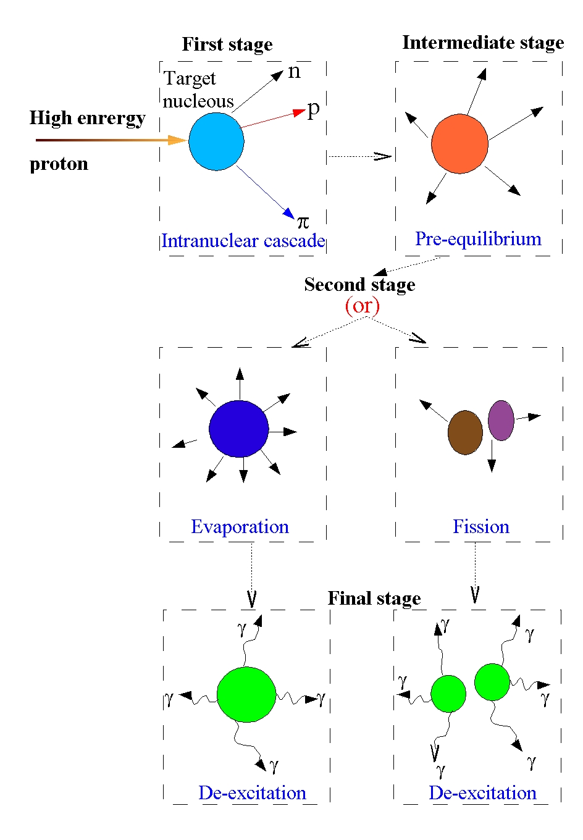
Fig. 1 Pictorial representation of high energy proton interaction with target nucleolus. In the fist stage the incident particle interacts of with individual nucleons [Intranuclear cascade (INC) phase]. This is followed by intermediate stage (pre-equilibrium). In both of these stages high energy light particles (dominated by neutrons) are emitted which then interact with other nuclei in the extended target (internuclear cascade). In the second stage the residual nucleus either undergoes evaporation releasing neutrons and light ions (with energies around 1 MeV) or fission. In the final stage the residual nucleus (or nuclei) de-excite via gamma emission.

The secondary neutron multiplicity depends on (1) incident particle type and energy (2) type of the target nucleus and (3) dimensions of the target[4]. Fig. 2 shows the variation of the neutron multiplicity with radius (r) of a cylindrical lead-target, for three different incident proton energies as calculated using MCNPX 2.5e Monte Carlo code[7]. The neutron multiplicity increases with increasing target radius and reaches a plateau value which is proton energy dependent.
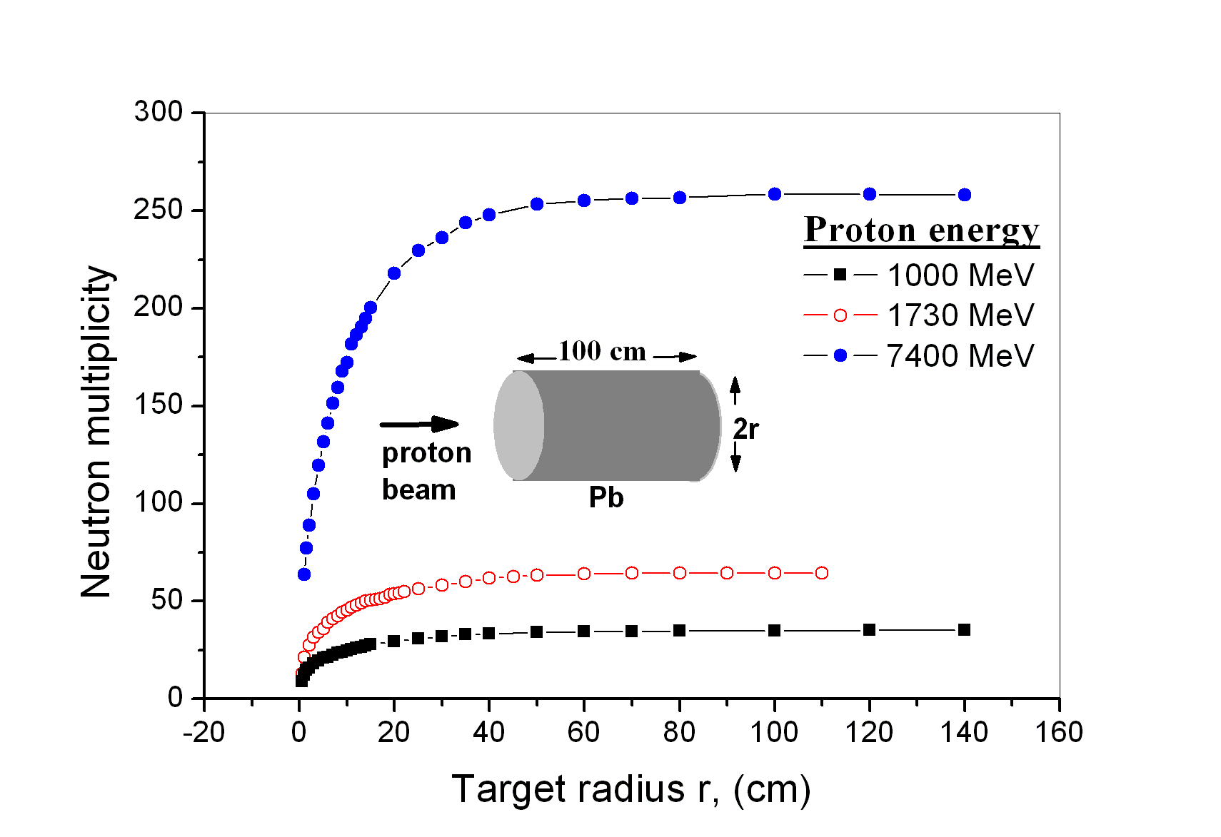
Fig. 2. Dependence of the secondary neutron multiplicity on incident proton energy and target size.
Fig. 3 shows the energy spectra of neutrons that emanate from a proton range length cylindrical lead target of diameter 20 cm when irradiated along its axis with protons of different energies, as calculated using the MCNPX code. It can be seen that, although the upper energy limit of the spallation neutrons varies with the incident proton energy the overall shape of the neutron spectrum does not change noticeably with the proton energy.
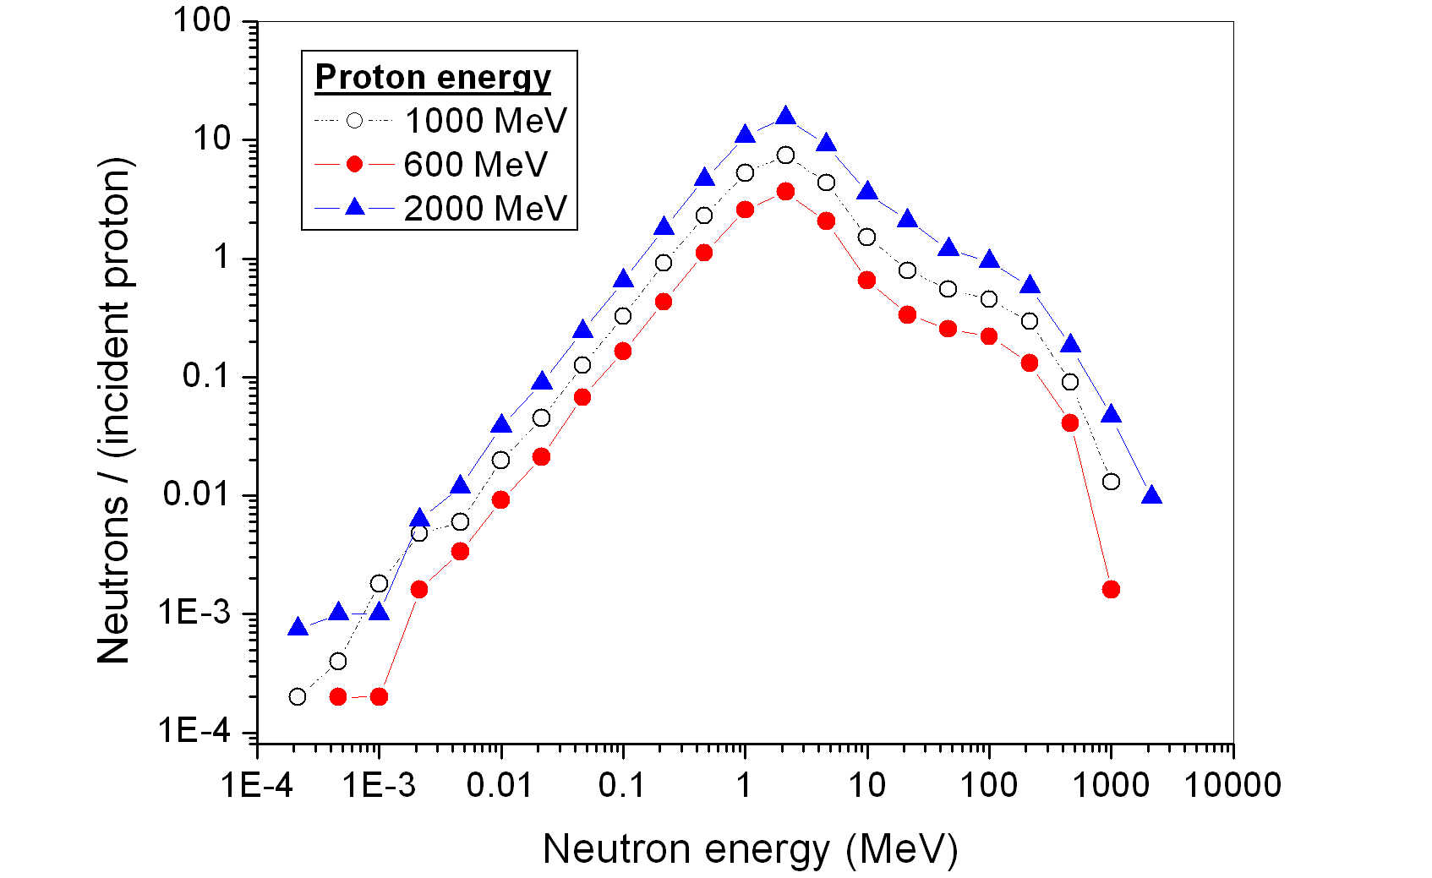
Fig. 3 The energy spectrum of the spallation neutrons at different incident proton energies. The lead target is a range long cylinder of diameter 20 cm.
The original idea of constructing a subcritical nuclear reactor (k_{eff} < 1) and introducing externally produced neutrons into the subcritical assembly in order to maintain a chain reaction is some times attributed to Tolestov (Joint Institute for Nuclear Research, JINR, Dubna, Russia, 1979)[8, 9], although his works were published only as JINR preprints. Bowman et al, (Los Alamos National Laboratory, LANL, USA, 1992)[10], suggested using neutrons produced in the interaction of high energy protons with a lead target to transmute long-lived radioactive waste nuclei into short-lived or into stable isotopes. Carlo Rubbia (CERN, 1993)[11], the joint winner of the 1984 Noble prize introduced this idea more openly into the public forum in scientific publications and public lectures.
A nuclear reactor operating under subcritical conditions and driven by an accelerator is generally referred to as an Accelerator Driven System (ADS). The CERN group uses the term Energy Amplifier (EA) for this type of reactor.
In an Accelerator Driven System, this external source consists of neutrons created by spallation process when a medium energy proton beam reacts with a heavy target. The supply of neutrons is proportional to the proton beam intensity.
As already mentioned the proposal to use a particle accelerator as a neutron supplier for a subcritical nuclear reactor is few decades old, it has become a realistic option due to recent massive progress in accelerator and computer technologies. After about seventy years of experience in accelerator technology the energy efficiency and reliability of these machines have reached an industrial level. Also progress in computing power as well as development of computer codes for study and simulations of particle and radiation production in nuclear interactions and their transport in complex systems, material behavior under different and extreme conditions, thermodynamics of the complex thermal systems, nuclear material burn up and production in the system etc allowed simulating in details the behavior of the Accelerator Driven Systems under different realistic conditions.
Problems associated with conventional critical thermal nuclear reactors
There are four major problems associated with the current conventional thermal nuclear reactors such as pressurized water reactors (PWR) or light water reactors (LWR),
- Inefficient use of the nuclear fuel in the current thermal reactors. The abundance of ²³⁵U, which is the main fuel of these reactors, has only ~1/140th of the abundance of the natural uranium. The remaining 99.3% of the mined uranium is not used in the fuel cycle.

- Production of long lived (in geological scale) nuclear waste.

- Safety issues and possibilities of nuclear accidents (however remote).

- Unavoidable production of fissile material (²³⁹Pu), which can be diverted to military applications.

The new generation of nuclear power plants must have solutions for all of these problems and Accelerator Driven subcritical reactors provide such solutions.

Solutions of the problems

Solution to the inefficient use of the nuclear fuel
The fuel of accelerator driven subcritical reactor is bred from natural thorium or uranium (²³⁸U) via the following reactions:
The end product of both reactions is fissile material that can be used as fuel in ADS. Both of these elements are abundantly available in Australia (especially Australia has worlds largest thorium reserves, 300,000 tons)[12].
In both of the above fuel breeding processes almost 100% of mined uranium or thorium can be converted to fissile material and burnt in the reactor.
Due to massive amount ²³⁹Pu productions in reaction 3 the uranium option must be carried under strict observation, supervision and control of the IAEA.
The ²³²Th option is preferred to ²³⁸U because thorium is more abundant than uranium in the earth’s crust (by a factor of 3-4), and because of other reasons given in the following.

Solution to the nuclear waste problem
- By using the more abundant fuel (thorium) very long-lived (geological scale) Plutonium and minor actinide radioactive waste will not be produced. It must be noted that in a uranium burning reactor most of the radiotoxicity of the spend fuel results from plutonium isotopes.

- As ADS operates in sub-critical conditions, a very large excess of neutrons are available in the system. The excess neutrons can be used to transmute long-lived radioactive wastes (such as the fission products) to short-lived or even stable isotope species via neutron capture process[13, 14]. For example
This method of nuclear waste transmutation is not available in conventional reactors due to the fact that these reactors operate in critical conditions and there are no excess neutrons available to be used for waste incineration.
The excess neutrons in the ADS also will be used for fuel production from ²³²Th via reaction (2) as already mentioned.
The excess neutrons in suitably designed ADS also can be used to transmute the stockpile of the nuclear waste that has been accumulated over the last 60 years operation of the conventional critical nuclear reactors[15]. The final nuclear waste of the ADS requires only ~ 500 years of storage time (which is manageable with today’s technology) to bring its activity to the level of coal ash [16]. This must be compared with the geological scale storage time required for the nuclear waste of the current nuclear reactors.
The long-lived nuclear waste isotopes of conventional reactors such as ²⁴¹Am, Cm isotopes and ²³⁹Pu can be incinerated by the fission process. In such cases not only the nuclear waste isotopes are destroyed but also a significant amount of energy is produced[13, 14, 17].
In other words, an ADS produces its own fuel and incinerates its own long-lived nuclear wastes as well as the waste from existing conventional critical reactors.
It must be mentioned that 1 kg of thorium if converted to fissile material and burnt in ADS can produce 8.3×10¹³ joules of thermal energy. This will result in much less than 1 kg of nuclear waste to be stored for ~500 years. If the same amount of energy is produced by coal it will result in 2.3×10⁷ kg of CO₂.

Solution to the nuclear safety issue
An ADS will operate under sub-critical conditions (e.g , k_{eff} = 0.95-0.98) and the operation of the reactor is directly linked to the operation of the attached accelerator which provides a high energy ion beam to produce spallation neutrons. These neutrons keep the ADS operational i.e. the system remains operational as long as the accelerator functions. The proton beam plays the role of the control bars in the current reactor, with the difference that if it fails, the fission reaction in the system dies out and it can never lead to overheating.
There are many ways to shutdown an accelerator (an electric device) or divert its beam away from the sub-critical reactor core.
Two major nuclear accidents (the Three Mile Island and the Chernobyl) both caused by critical power excursions.
Moreover an ADS fuelled with thorium does not contain ²³⁸U and therefore will not breed ²³⁹Pu which can be diverted to military applications. In a thorium fuelled ADS the approximate uranium isotope mixture in the subcritical core after an integrated neutron exposure of 3×10²² cm⁻² will be[11]; ²³³U (44%), ²³⁴U (30%), ²³⁵U (4%), ²³⁶U (22%) and ²³⁸U (negligible). A very difficult and extremely intensive isotope separation is required to separate “weapon grade” ²³³U from this type of mixture.

Overall cost of electricity production via ADS
Although cost of energy production by means of uranium burning conventional reactors is lower than that of the coal powered power stations[18] it would be favorable if this cost is further reduced. The cost of energy productions by ADS using thorium will be less than that of the current nuclear reactors because;
- Thorium is much more abundant than uranium in the Earth’s crust and therefore cheaper.
- Almost all of the ²³²Th can be converted to ADS fuel.
- No fuel enrichment and associated cost is required.
- The control system of the ADS will be much less sophisticated than that of the current reactors and therefore less expensive.

Detailed analyses have shown that the cost of the energy production by ADS is ~ 2c per kWh[19].

Accelerator requirements
Fig. 4 show the variation of the neutron multiplicity with energy of the incident proton for a range long lead target of diameter 20 cm as calculated using the MCNPX 2.5e code[7]. The energy gain of an ADS is defined as where P_{out} and P_{in} are output and input thermal powers respectively. The G is directly proportional to the energy cost of the neutron production (np/E_{p}), where np is the number of the spallation neutrons per proton of energy E_{p} on the target[4]. From Fig. 4, it can be seen that (np/E_{p}) and therefore the G reaches to a plateau value at energies E_{p} > 1 GeV.
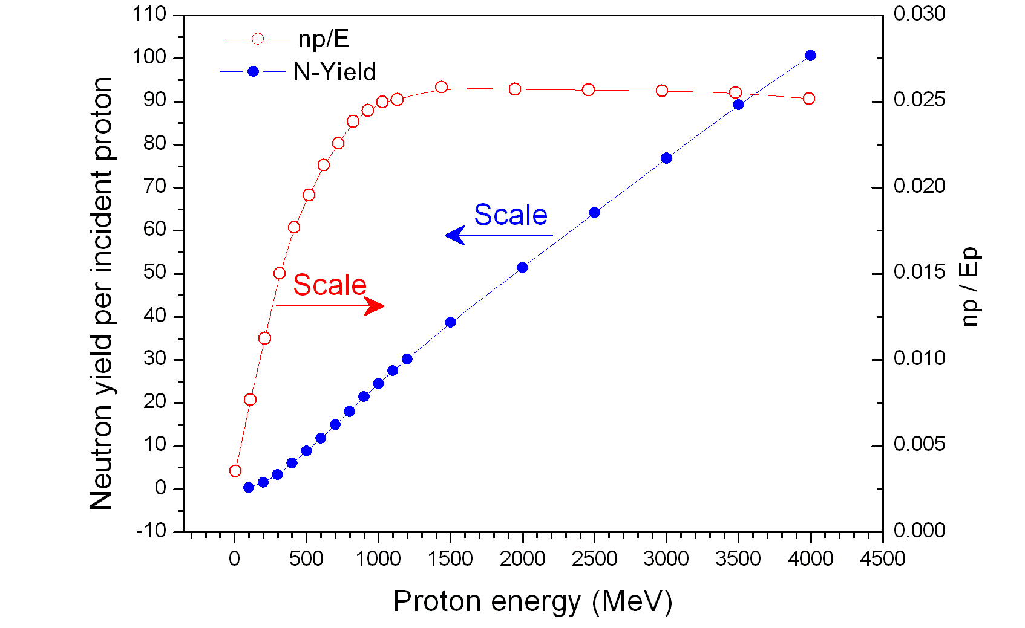
Fig. 4 Variations of the neutron multiplicity np, and neutron yield per unit energy of the incident proton (np/E_{p}) as a function of incident proton energy. The energy gain of an ADS is directly proportional to np/E_{p}. Calculations were preformed using MCNPX code.
Fig. 4 suggests that a 1 GeV proton accelerator will be adequate to achieve about the maximum gain. With the neutron multiplicity 24.5 neutrons per 1 GeV proton (Fig. 4) a subcritical assembly with k_{eff} = 0.95 or k_{eff} = 0.98 (extremely safe operational level) coupled with an accelerator which provides a proton beam with integrated proton current of 10 mA (beam power of 10 MW) will have a thermal energy gain of 37 and 96 respectively[4]. Such an ADS will produce 370 MW_{th} at k_{eff} = 0.95 and 960 MW_{th} at k_{eff} = 0.98. Obviously higher powers will be produced at higher beam currents.
A certain fraction of the ADS electric output power must be feedback to run the coupled accelerator. The electric power required to obtain a proton thermal beam power of P_{in} is P_{in}/ξ where ξ is the electric to beam power conversion efficiency of the accelerator. For modern accelerators ξ is about 0.5. Also there is a heat loss in conversation of the thermal to electric power, efficiency of which is η ~ 0.42. Therefore fraction of the output power required for accelerator operation will be
(4)
Thus for k_{eff} = 0.95 and k_{eff} = 0.98, f will be 13% and 5% respectively.

Basic principles of the ADS operation

The basic principles of the operation of an ADS are shown in Fig. 5. When this pictorial representation of the ADS is compared with that of the conventional thermal reactors it becomes obvious that the design of a subcritical nuclear reactor will not be dramatically different from that of the conventional reactor. This by itself is an advantage because over 60 years of experience with nuclear reactors can and will be an asset and foundation in design and operation of this new generation of reactors. However major effort must be put to the design of accelerator, beam window, spallation target and fuel rods. Also the type of material that can be used in an ADS must be radiation resistant and can handle large exposure to high energy nuclear particles.

An ADS like any other reactor has a core which in this case has fuel elements made of pellets composed of mixed oxides (MOX) of ²³²ThO2 and ²³³UO2 enclosed in an appropriate cladding. The initial amount of the ²³³U in the rods is for startup purposes, during the ADS operation the consumed ²³³U will be replaced by ²³³U bred from ²³²Th according to the reaction (2). The core and ADS as whole designed in a way that k_{eff} < 1. The spallation target is positioned between the fuel rods in the core. The beam of protons from a high-power accelerator is directed towards the spallation target (e.g. lead) to produce spallation neutrons and thus sustain the chain reaction in the system. The reactor core and target are embedded within an environment that acts as neutron and heat storage medium as well as the neutron moderator. We will refer to this medium as M-medium. The type of the material that can be used for M-medium depends on the type of the ADS whether it is a fast or thermal ADS and it must be compatible with the type of the material used for cladding. For fast ADS it is proposed to use the lead as both target and M-medium[16]. In such a case the M-medium will be molten lead.

If material of the M-medium is different from that of the target then target must be enclosed in a leak proof container made of a substance that is corrosive resistant and has high thermal conductivity and high melting point. Tungsten can be a good candidate for this purpose. As most of the energy deposition by the beam happens within the first 20 cm of the target length and considering the beam power of more than 10 MW such a target-system must rapidly dissipate the absorbed heat to the surrounding medium.

The ADS control unit can be equipped with temperature, neutron and other sensors, which will send electronic signals to the accelerator if reading level(s) exceed desired limit, triggering beam abort away from the core. Extra redundant safety units such as those used in conventional reactors can also be added for further safety.

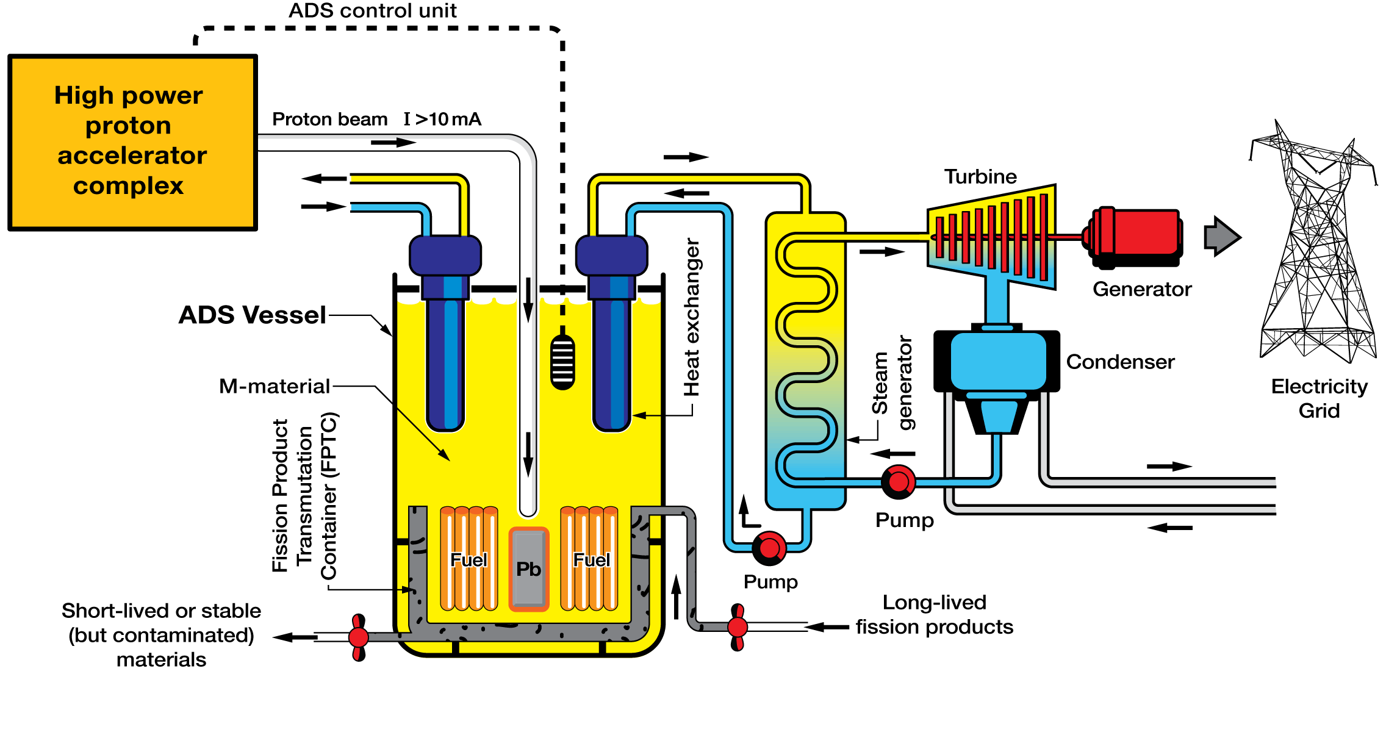
Fig. 5. An Accelerator Driven System equipped with a long-lived fission product transmutation (incineration) facility. A high power proton accelerator is coupled to the subcritical assembly producing spallation neutrons in the lead target which sustain the chain reaction in the core. The fuel rods are made of mixed oxides of thorium and U-233 (or plutonium and minor actinides from the nuclear waste of the conventional reactors). M-material in the diagram referrers to the environment that acts as neutron and heat storage medium as well as neutron moderator.

The heat produced by the fission of the fissile material in the core is stored in the M-medium from which it is transferred to the heat exchangers and electricity generating units in conventional manner.

Inside the reactor vessel and in the vicinity of the core we have placed a fission product transmutation container (FPTC). This is used to consume the available excess neutrons in the system for transmutation of the long-lived fission product isotopes such as ¹²⁹I and ⁹⁹Tc. The FPTC is accessible from the outside of the main reactor vessel for loading and discharging the waste in liquid phase.

To exploit all the capabilities of the ADS, its fuel must follow a closed cycle. That is the spent fuel must be processed and partitioned according to the best available methods and technologies. Fig. 6 shows different stages of the closed ADS fuel cycles. After initial cooling stage of the spent fuel, the fissile materials and unused thorium in the spent fuel are separated and are used in new fuel rod fabrication. The long-lived and transmutable fission products are separated for injection into the FPTC. The final un-transmutable wastes are sent to an appropriate waste storage facility where they will be kept for a period of about 500 years. Today’s technology allows us to be confident that such a waste storage will be safe and environmentally harmless.

Obviously the nuclear waste that can be used as fuel and transmutation material is not limited to the waste produced by the ADS itself. In the fabrication of the ADS fuel rods the waste from the conventional critical reactors can be and will be used as well. This provides the long awaited solution for the public concern on the stockpiles of the nuclear waste produced over the last 60 years of operation of nuclear reactors.

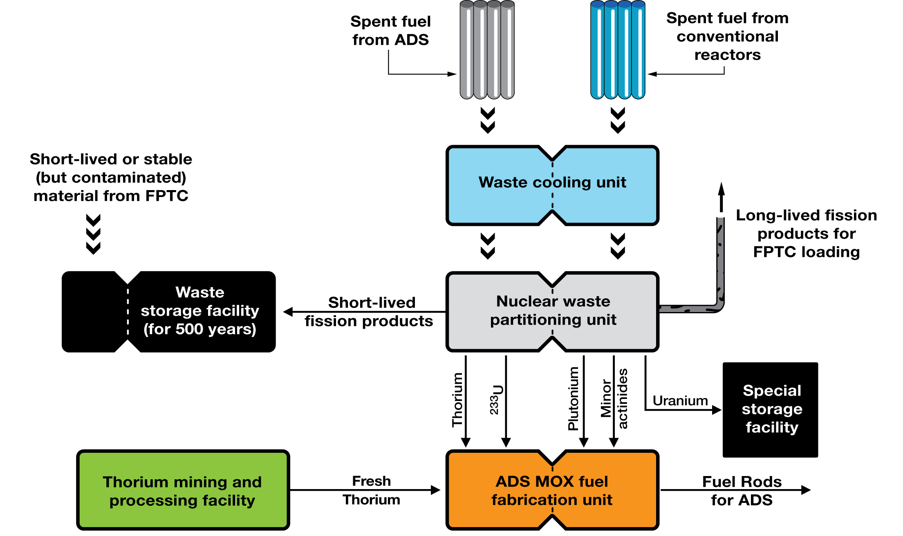

Fig. 6. A closed fuel cycle for ADS. The MOX fuel refers to the one that is made of mixed oxides of the fissile materials.

Some predictions for future electricity generation in Australia

The electricity generation from fossil fuels, especially coal, will continue for many years although in an improved and more environmentally friendly manner. Due to the massive world demand for energy, the export of the coal and natural gas will not be reduced as a result of installations of the nuclear power plants in Australia and other parts of the world for several decades to come.

Activities in R&D and eventually production of energy from renewable sources will continue and even may accelerate.

For immediate economical, environmental and geopolitical reasons it is not difficult to predict that Australia’s initial involvement in the field of nuclear energy will be in terms of conventional generation three thermal nuclear reactors. Alongside of which uranium enrichment and fuel processing plants will be established. However it will not be possible to avoid ADS technology because of the fact that this type of nuclear system provides the only known and logical method for handling, managing and eliminating the dangerous and environmentally harmful nuclear waste. Australia’s future nuclear power plants beyond those that may be installed after the conclusion of the current nuclear debate will be ADS technology because of the massive thorium recourses of Australia, the safety of these reactors and the cleanness of energy production by the ADS method.

It must be mentioned that involvement in ADS research and development and eventually installations of thorium based Accelerator Driven Systems in Australia will not affect the uranium export. This is due to the number of existing commercial uranium burning nuclear reactors in world (441) and those that are under construction (~15) and those that will be constructed in the future (including those in Australia). The demand for uranium in the world market not only will not decrease but it is expected to increase as fossil fuels become scarcer and willingness for their massive use diminishes.

The impact of the ADS technology to the Australian economy is enormous. Calculations show that if the known thorium resources of Australia (300,000 tonnes) are burnt in accelerator driven sub-critical reactors, it will provide an energy equivalent of 4.3×10¹² barrels of oil. This amount is equivalent to 5800 years of oil export, at a rate of 2 million barrels per day (similar to that of a major oil producing country in the Persian Gulf) or an income of ~ AUS$70×10⁹ (US$52×10⁹) per year for 5800 years at today’s oil price.
Accelerator driven subcritical nuclear reactors besides producing clean and cheap energy, provide a unique solution for the elimination of plutonium, minor actinides and long-lived fission products in conventional nuclear reactor waste as well as the plutonium from warheads: one of mankind’s unnecessary, unwise, self-destructive, cruel and crude technical achievements, for a peaceful and environmentally clean Earth.

Reference

[1] M. Beniston, Geophys. Res. Lett. 31, L02202, doi:10.1029/2003GL018857 (2004)
[2] M. Beniston, Geophys. Res. Lett. 32, L01812, doi:10.1029/2004GL021478 (2005)
[3] S. Levitus, J. Antonov, and T. Boyer, Geophys. Res. Lett. 32, L02604, doi:10.1029/2004GL021592 (2005)
[4] S. R. Hashemi-Nezhad, R. Brandt, W. Westmeier, V. P. Bamblevski, M. I. Krivopustov, B. A. Kulakov, A. N. Sosnin, J.-S. Wan, and R.Odoj, Kerntechnik 66 (2001) 47.
[5] K. van der Meer, M. B. Goldberg, E. H. Lehmann , H. Aït Abderrahim , D. Bar , D. Berkovits , M. Daum , S. Dekelver , Y. Foucher , J. Gerber , and e. al., Nucl. Instr. and Meth. B 217 (2004) 202.
[6] R. G. Vassilkov, Y. M. Chirkin, and N. S. Myhzin, Atomic Energy 79 (1995) 257.
[7] J. S. Hendricks, G. W. McKinney, L. S. Waters, T. L. Roberts, H. W. Egdorf, J. P. Finch, H. R. Trellue, E. J. Pitcher, D. R. Mayo, M. T. Swinhoe, S. J. Tobin, F. X. Gallmeier, J.-C. David, W. B. Hamilton, and J. Lebenhaft, MCNPX, VERSION 2.5.e, Report No. LA-UR-04-0569, Los Alamos National Laboratory, February 2004.
[8] K. D. Tolstov, Some aspects of accelerator breeding, Preprint 18 - 89 - 778, Joint Institute for Nuclear Research, Dubna, Russia, 1989.
[9] K. D. Tolstov, The modeling of electro-nuclear method of atomic energy production and radioactive waste transmutation, Preprint 18 - 92 - 303, Joint Institute for Nuclear Research, Dubna, Russia, 1992.
[10] C. D. Bowman, E. D. Arthur, P. W. Lisowski, G. P. Lawrence, R. J. Jensen, J. L. Anderson, B. Blind, M. Cappiello, J. W. Davidson, T. R. England, L. N. Engel, R. C. Haight, H. G. Hughes, J. R. I. III , R. A. Krakowski, R. J. LaBauve, B. C. Letellier, R. T. Perry, G. J. Russell, K. P. Staudhammer, G. Versamis, and W. B. Wilson, Nucl. Instr. and Meth. A 320 (1992) 336.
[11] F. Carminati, R. Klapisch, J. P. Revol, C. Roche, J. A. Rubio, and C. Rubbia, An energy amplifier for cleaner and inexhaustible nuclear energy production driven by a particle beam accelerator, Preprint, CERN/AT/93-47-ET, 1993.
[12] US Geological Survey, see, http://minerals.usgs.gov/minerals/pubs/commodity/thorium/thorimcs06.pdf.
[13] W. Westmeier, R. Brandt, E.-J. Langrock, H. Robotham, K. Siemon, R. Odoj, I. Adam, V. Bradnova, V. M. Golovatyuk, V. A. Krasnov, M. I. Krivopustov, V. S. Pronskikh, A. N. Sosnin, V. M. Tsoupko-Sitnikov, N. M. Vladimirova, S. R. Hashemi-Nezhad, and M. Zamani-Valasiadou, Radiochimica Acta 93 (2005) 65.
[14] J. Adam, J. C. Adloff, A. Balabekyan, V. P. Bamblevski, M. Y. Barabanov, R. Brandt, V. Bradnova, P. Chaloun, M. Debeauvais, K. K. Dwivedi, S.-L. Guo, S. R. Hashemi-Nezhad, V. G. Kalinnikov, K. M. Hella, M. K. Kievits, M. I. Krivopustov, B. A. Kulakov, E.-J. Langrock, L. Li, E. M. Lomonossova, G. Modolo, R. Odoj, V. P. Perelygin, V. S. Pronskikh, A. A. Solnyshkin, V. I. Stegialov, V. M. Tsoupko-Sitnikov, P. Vater, J.-S. Wan, W. Westmeier, M. Zamani-Valasiadou, and I. V. Zhuk, Radiochimica Acta 90 (2002) 431.
[15] Physics and Safety of Transmutation Systems; A Status Report, Nuclear Energy Agency, OECD, NEA No. 6090, ISBN 92-64-01082-3, 2006.
[16] C. Rubbia, S. Buono, Y. Kadi, and J. A. Rubio, A realistic Plutonium elimination scheme with fast energy amplifier and thorium-plutonium fuel, CERN/AT/95-53 (ET), 1995.
[17] S. R. Hashemi-Nezhad, R. Brandt, W. Westmeier, V. P. Bamblevski, M. I. Krivopustov, B. A. Kulakov, A. N. Sosnin, J.-S. Wan, and R.Odoj, JINR Report E1-2001-44 and Nucl. Instr. and Meth. A 482 (2002) 537.
[18] The Cost of Generating Electricity, The Royal Academy of Engineering, London, ISBN 1-903496-11-X, 2004.
[19] R. Fernandez, P. Mandrillon, C. Rubbia, and J. A. Rubio, A preliminary estimate of the economic impact of the energy amplifier, Preprint, CERN/LHC/96-01- EET, 1996.

This article is published under the title “Accelerator Driven Sub-critical Nuclear Reactors” in, Australian Physics, Vol. 43 No. 3, (2006), 90-96.
Corresponding author; Tel: +61 2 93515964, Fax: +61 2 93517726, email: reza@physics.usyd.edu.au

